

UNIFORM POLICY

At Virginia Primary we are very proud of our learning environment and the sense of belonging to a supportive community that we develop and provide for our students. Hence our motto “Learning together, Learning for our future”.

The sense of identity is also developed in students through the implementation of a school uniform. We have a recognised school uniform and policy which is strongly supported by our community, students and staff. It is an expectation that the uniform is worn by all students. We also believe that the school uniform promotes student safety, and is practical and inexpensive.

Essential elements of the school uniform are:

TOPS
Virginia Primary School striped polo. Both short and long sleeves are acceptable.
Plain navy windcheater with school logo.
Plain navy zip front jacket with school logo.

PANTS
Pants are to be plain navy all over. This includes track pants, shorts, skorts or cotton fleece pants.

DRESSES & SKIRTS
Plain navy skirts or skorts (to sit no higher than just above the knee)
Navy / white checked uniform dress.

HATS & HEADWEAR
In accordance with our sun smart policy it is expected that all students wear a navy broad brimmed Virginia Primary School hat while in the yard. Baseball hats are not appropriate. Hair accessories must be plain, blue or yellow in colour.

FOOTWEAR
Footwear needs to be within health and safety guidelines, sports shoes, secure and sturdy school sandals eg no thongs, high heels etc.

JEWELLERY/ MAKE-UP/NAILS
Again in the interests of student safety, jewellery must be kept to a minimum, eg small sleepers, studs. Necklaces/ bracelets should not be worn (medical or religious/ cultural necklaces are exempt but must be kept tucked under tops where appropriate) Coloured nail polish, false nails and make-up of any sort is also not appropriate.

Please note that jeans are not part of the uniform, clothing must be plain navy blue only; no stripes, no patterns, no royal or light blues etc.

NO LOGOS OTHER THAN SCHOOL LOGOS
Students who are not in uniform will be asked to change into uniform or play in a designated area of the yard.

We understand that there are occasions when there are exceptional circumstances.
If this is the case, please write a note to the class teacher.

We thank you for your ongoing support in this area.

Virginia Primary Uniform List

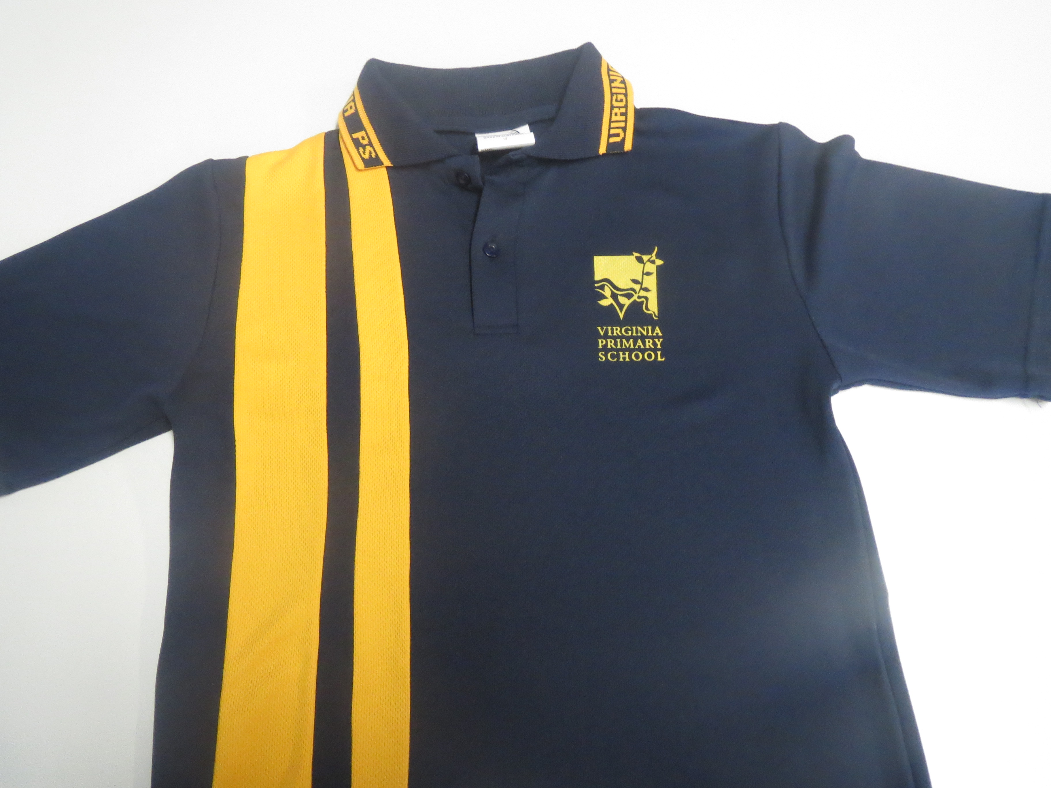
Short sleeve polo top Long sleeve polo top
Sizes 4 – adults large Sizes 4 – adults large
$30 $35

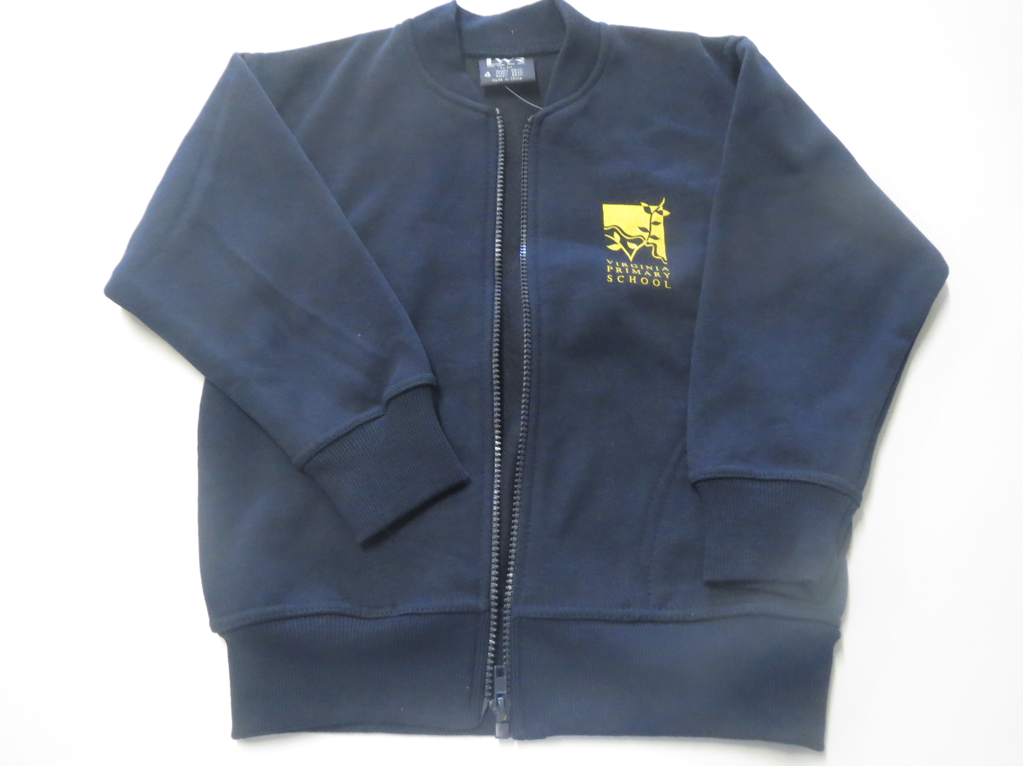
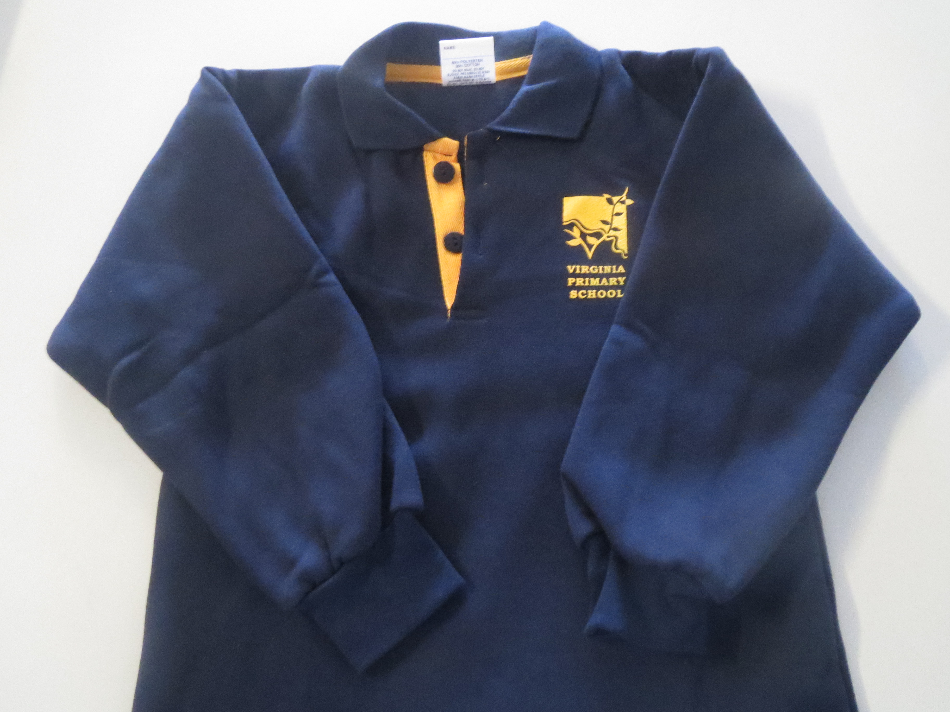
Fleece Zip Jacket Fleecy jumper
Sizes 4 – adults large Sizes 4 – 16 $35
$28 Sizes Sm - XL $37

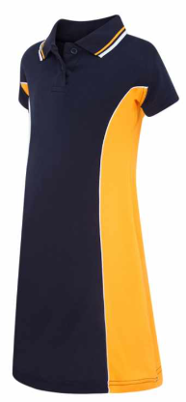
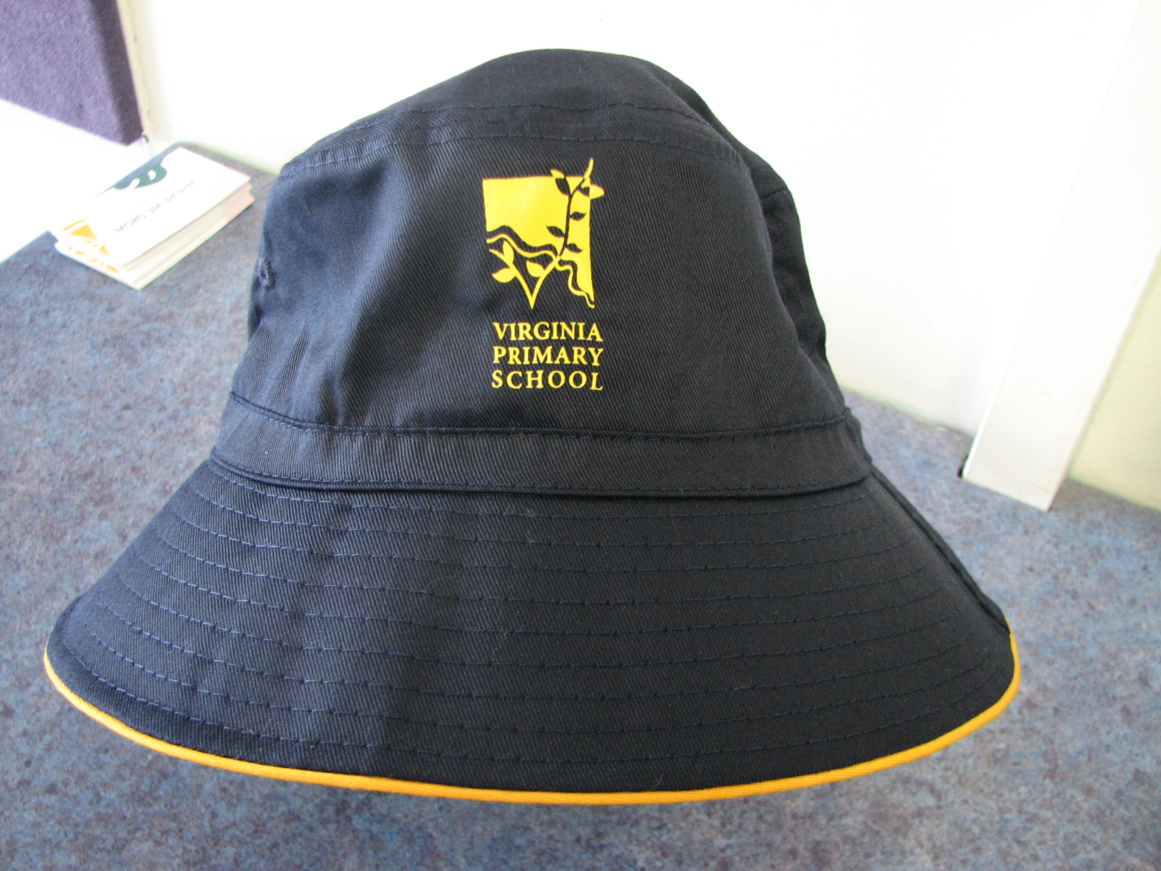
**NEW** Bucket Hat
Harper Polo dress (with logo) X small – X large
Sizes 4 – 16 $12
$30

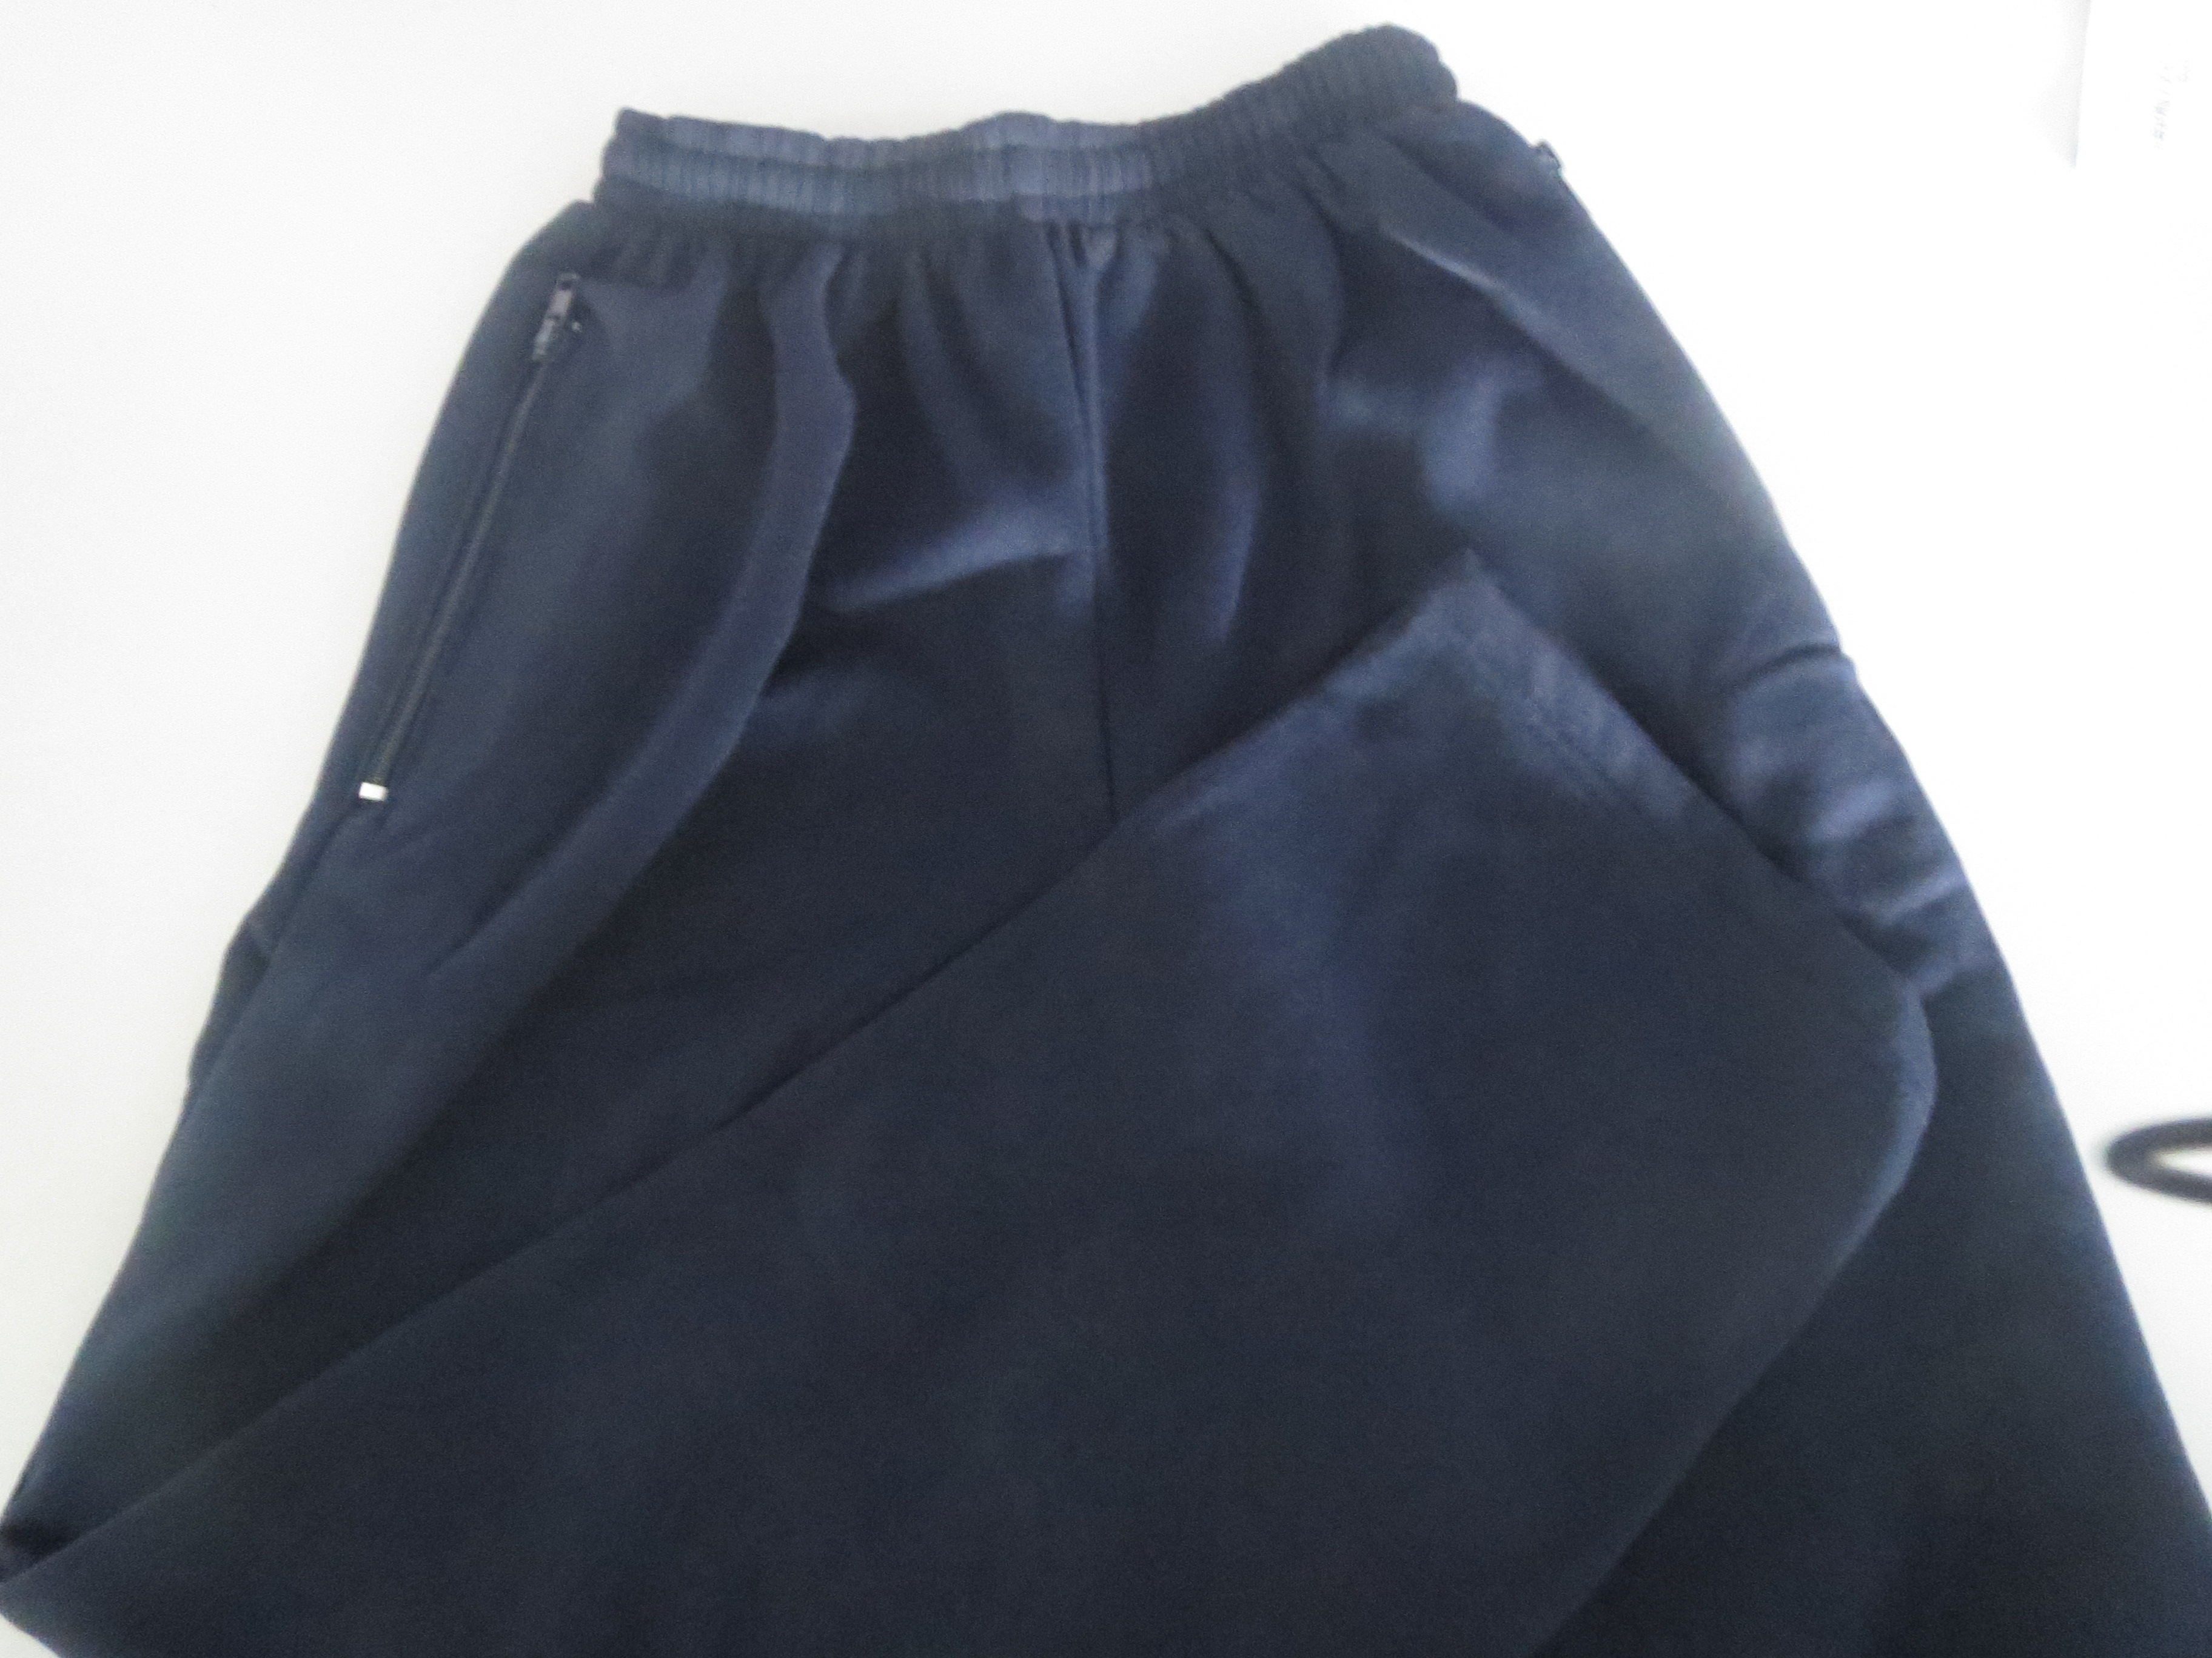
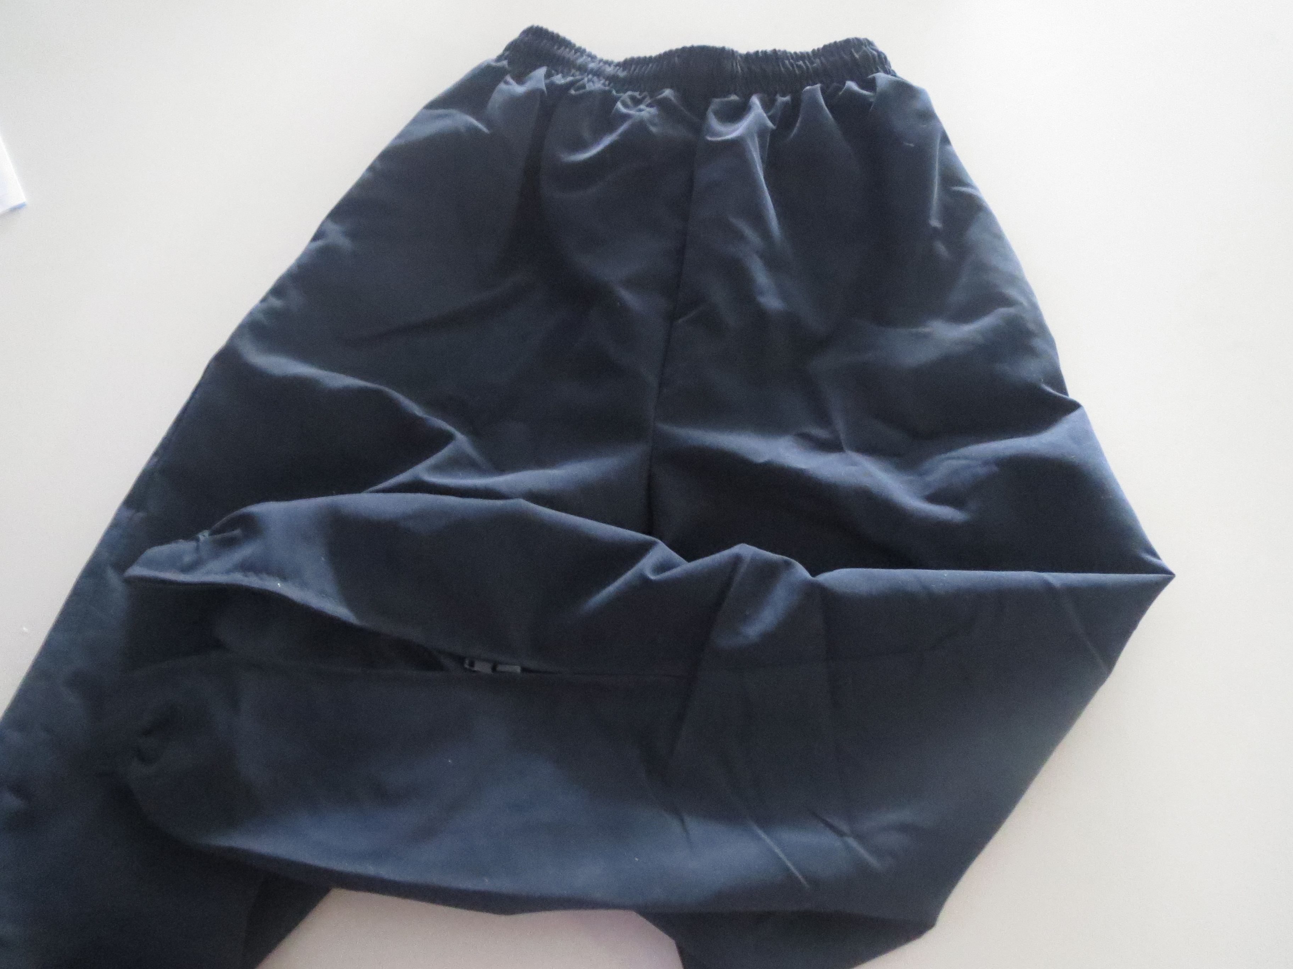

Fleecy Track Pant Microfibre Track Pant
Sizes 4 – 16 Sizes 4 – 16
$18 $25

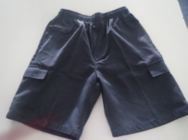
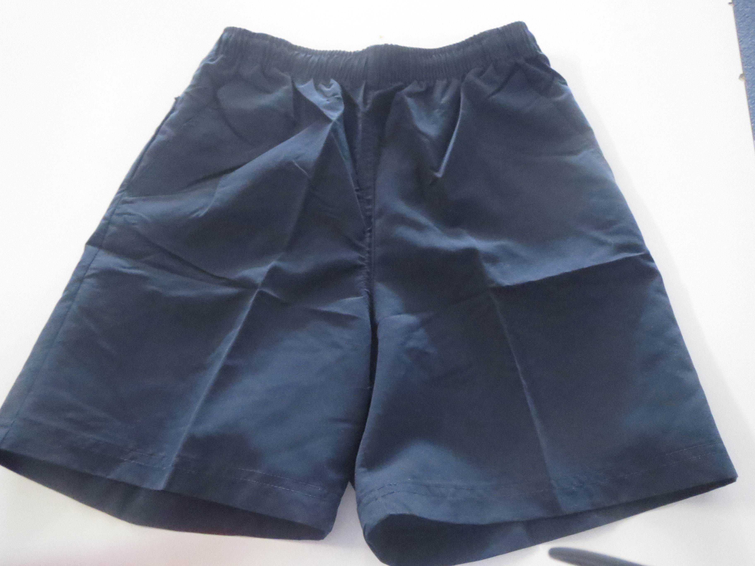

Cargo Shorts Microfibre Shorts
Sizes 4 – adults large Sizes 4 – adults large
$18 $15

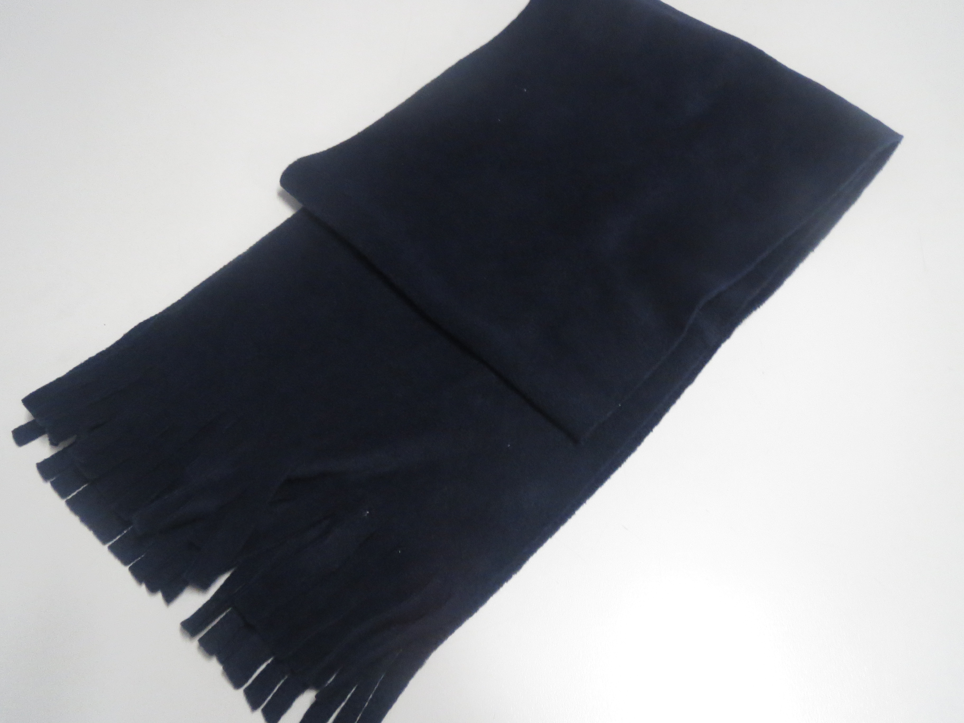
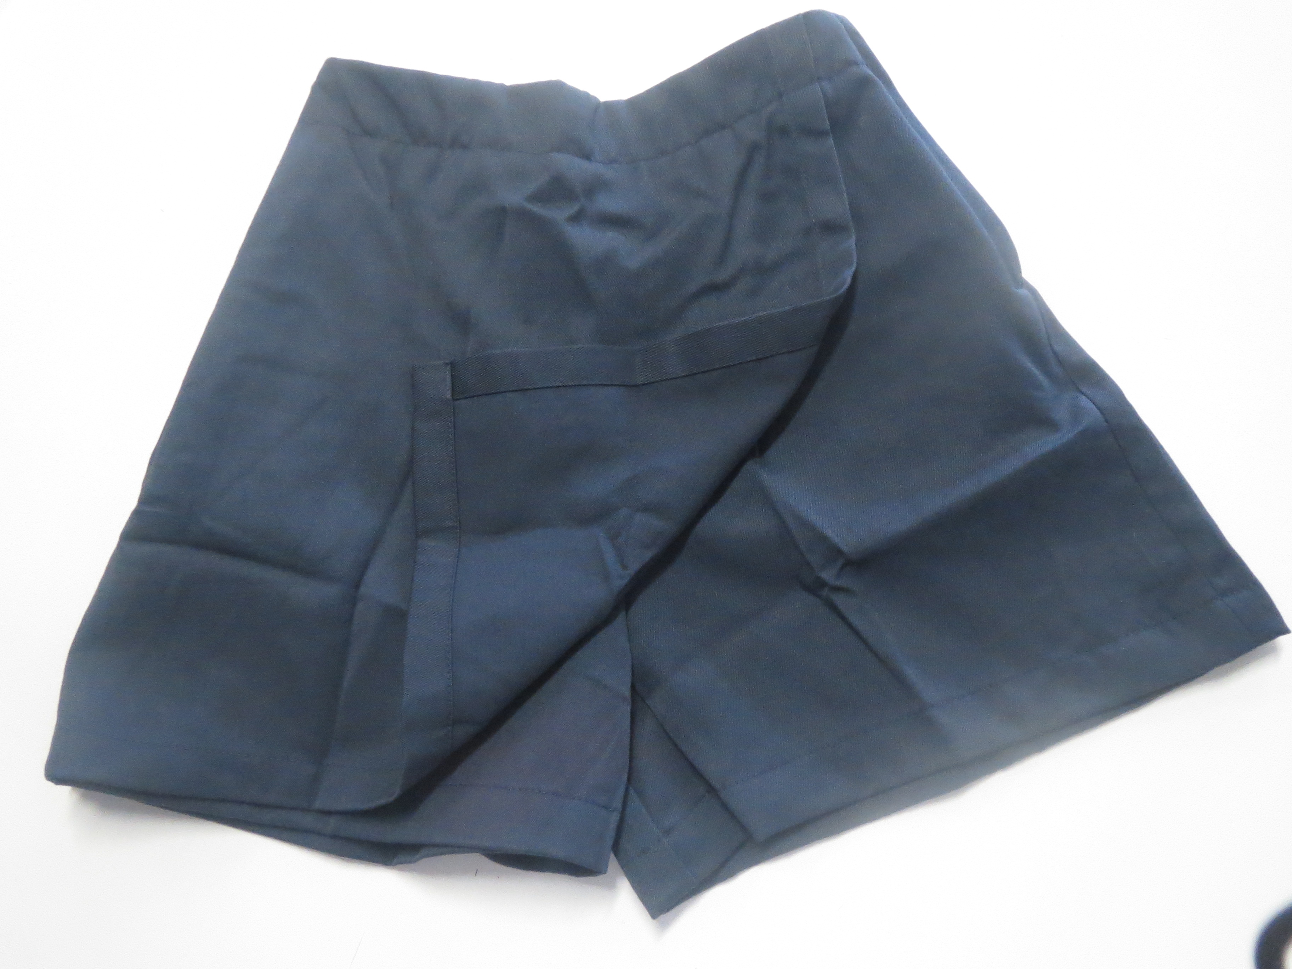

Skort Polar Fleece Scarf
Sizes 4 – 16 $8
$16

